Pat yourself on the back, because you've come a long way.
At this point in the course you have already defined all of your AJAX APIs and set up server routes to listen for those requests.
In other words: you've done the hard slog.
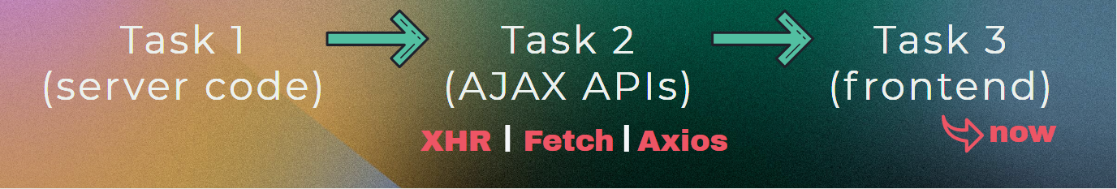
This final section is merely adding a little design flare (and yes, some JavaScript) to glue all of our puzzle pieces together.
I can't wait.

